1. Scenarios

**Scenario in Cucumber:**

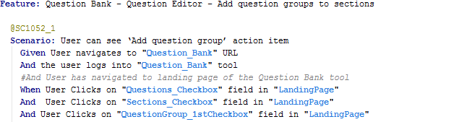

**Scenario in Jasmine:**

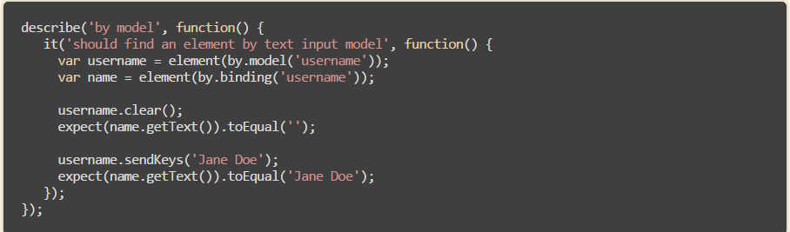

2. Step definition Reusability is not there in Jasmine. We can create a common step definitions and we can reuse these on all the feature files

3. Jasmine is good for unit testing and Cucumber is Good for functional Testing

4. Aligning the Gherkin script is easy in Cucumber using Feature file where as in Jasmine we cannot write Feature file

5. Maintenance is very easy in Cucumber if any changes in requirement but it will be difficult in Jasmine because in Jasmine we need to update in all the step definitions

6. Cucumber feature file contains Plain English like statements so it will be very easy to understand for entire team ( BA,Dev,etc)

7. Easy to segregate the Automation scripts for executing based on the mentioned Tags in Cucumber. Example are Smote Scenarios, Regression scenarios etc. see @PE-1052 in the below code

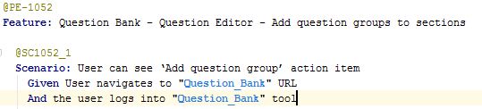

Whereas this feature is not available in Jasmine

8. **Scenario outline:** Gherkin scripts can include data files in pipe delimited format. Here is an example

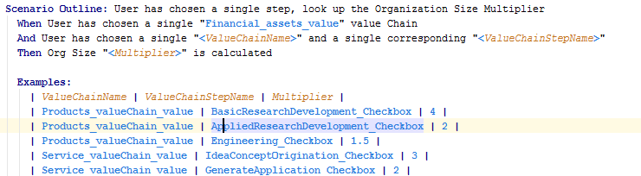

In this example the pipe- delimited data file will drive the AND and THEN line of the Gherkin script 5 times and will thus drive the scenario 5 times.

This we cannot achieve directly in the Jasmine.